**LAB NOTEBOOK**

**SWASTI KUMARI**

**Summer internship**

**Beginning 26 May 26, 2025**

**Monday, May 26, 2025**

**Chapter 5. Flow Control**

**Topic:** Flow Control- if-else, return, and exit

Today, I explored key flow control concepts in Bash scripting that help automate tasks and manage execution behaviour efficiently.

**1. if-else Statements**

* The if statement allows conditional execution based on whether an expression is **true (exit status 0)** or **false (exit status ≠ 0)**.
* **Example: Checking if a file exists**

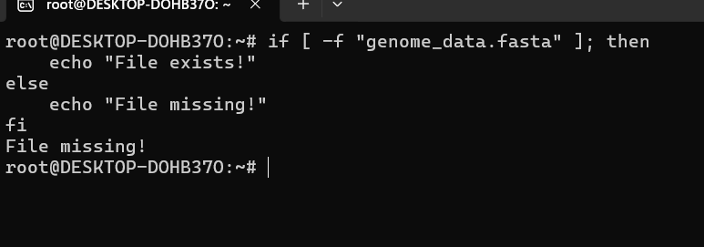

**2. return Statement in Functions**

* Used **only inside functions** to exit and pass an exit status.
* Syntax: return N (where N is an integer between 0-255).
* Example:

**3. exit Statement**

* Terminates **the entire script**, unlike return, which only exits a function.
* Syntax: exit N (similar to return).